**Experiment – 4**

1. **Add a CSS media query and appropriate styles so that the webpage looks similar even when resized to smaller widths. Specifically:**

**The sidebar should be hidden.**

**The body should have no padding.**

**The images shouldn't exceed the width of the window.**

**The navigation items should each be on their own line.**

**The header should be fixed, so that it stays at the top after scrolling.**

**Ans:**

**HTML Code:**

<!DOCTYPE html>

<html lang="en">

<head>

  <meta charset="UTF-8">

  <meta name="viewport" content="width=device-width, initial-scale=1.0">

  <title>Your Page Title</title>

  <link rel="stylesheet" href="styles.css">

</head>

<body>

  <header>

    <h1>Your Website</h1>

  </header>

  <nav>

    <ul>

      <li><a href="#">Home</a></li>

      <li><a href="#">About</a></li>

      <li><a href="#">Services</a></li>

      <li><a href="#">Contact</a></li>

    </ul>

  </nav>

  <main>

    <section>

      <h2>Main Content</h2>

      <!-- Your main content goes here -->

    </section>

  </main>

  <aside>

    <h2>Sidebar</h2>

    <!-- Your sidebar content goes here -->

  </aside>

  <footer>

    &copy; 2024 Your Website. All Rights Reserved.

  </footer>

</body>

</html>

**CSS Code:**

/* Default Styles */

body {

*font*: 16px Sans-Serif;

*padding*: 20px;

  }

  header {

*background*: #42A5F5;

*color*: white;

*padding*: 20px;

*position*: relative;

  }

  header h1 {

*margin*: 0;

  }

  nav {

*background*: #eee;

*padding*: 20px;

  }

  nav ul {

*list-style-type*: none;

*margin*: 0;

*padding*: 0;

  }

  nav li {

*display*: inline-block;

*margin-right*: 20px;

  }

  nav a {

*text-decoration*: none;

*color*: #000;

*transition*: transform 0.3s ease-in-out;

  }

  nav a:hover,

  nav a:focus {

*transform*: translateY(-5px);

*color*: #42A5F5;

  }

  main {

*padding*: 20px;

  }

  img {

*max-width*: 100%;

*height*: auto;

  }

  aside {

*background*: #eee;

*padding*: 20px;

  }

  footer {

*background*: #42A5F5;

*color*: white;

*line-height*: 50px;

*padding*: 0 20px;

*margin-top*: 20px;

  }

  /* Media Query Styles */

  @media screen and (*max-width*: 768px) {

    header {

*position*: fixed;

*top*: 0;

*left*: 0;

*right*: 0;

*z-index*: 100;

    }

    nav li {

*display*: block;

*margin*: 10px 0;

    }

    main {

*padding*: 0;

    }

    aside {

*display*: none;

    }

    img {

*max-width*: 100%;

*height*: auto;

    }

  }

**Output:**

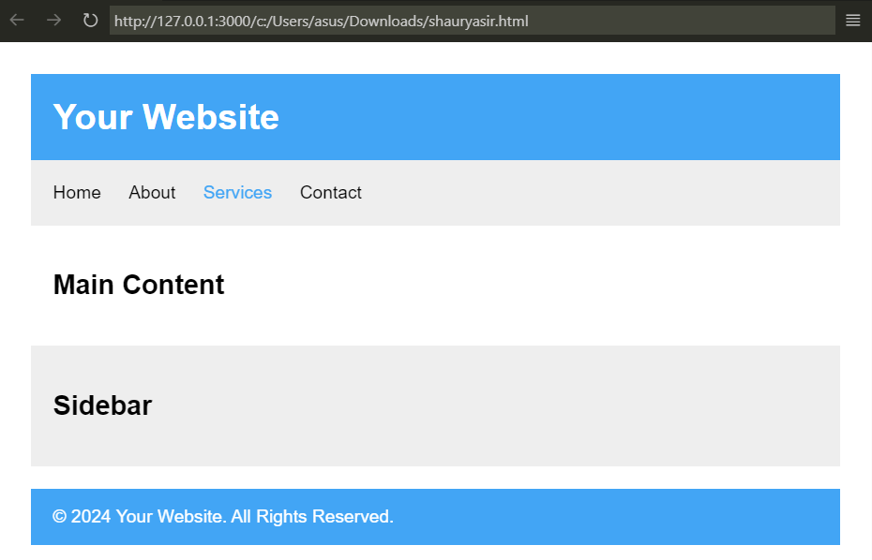

**Experiment – 5**

1. **Write a JavaScript program that displays the largest integer among two integers.**

**Ans:**

*function* max_townums_range(*x*, *y*) {

    if (*x* >= 40 && *x* <= 60 && *y* >= 40 && *y* <= 60) {

      return *x* === *y* ? "Numbers are the same" : (*x* > *y* ? *x* : *y*);

    } else {

      return "Numbers don't fit in range";

    }

  }

  console.log(max_townums_range(45, 60));

  console.log(max_townums_range(25, 60));

  console.log(max_townums_range(45, 80));

**Output:**

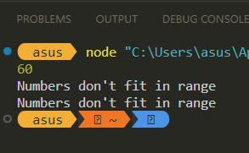

1. **Write a JavaScript function that accepts a string as a parameter and converts the first letter of each word into upper case.**

**Ans:**

*function* capitalizeFirstLetterOfWords(*str*) {

    return *str*.split(' ').map(*word* *=>* {

      return *word*.charAt(0).toUpperCase() + *word*.slice(1);

    }).join(' ');

  }

  console.log(capitalizeFirstLetterOfWords('hello world'));

  console.log(capitalizeFirstLetterOfWords('the quick brown fox'));

**Output:**

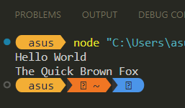

1. **Write a Java Script to create a simple calculator.**

**Ans:**

*const* readlineSync = require('readline-sync');

*function* calculator(*operation*, *num1*, *num2*) {

  switch (*operation*) {

    case 'add':

      return *num1* + *num2*;

    case 'subtract':

      return *num1* - *num2*;

    case 'multiply':

      return *num1* * *num2*;

    case 'divide':

      if (*num2* === 0) {

        throw new *Error*('Division by zero is not allowed');

      }

      return *num1* / *num2*;

    default:

      throw new *Error*('Invalid operation');

  }

}

*const* operation = readlineSync.question('Enter the operation (add, subtract, multiply, divide): ');

*const* num1 = parseFloat(readlineSync.question('Enter the first number: '));

*const* num2 = parseFloat(readlineSync.question('Enter the second number: '));

try {

*const* result = calculator(operation, num1, num2);

  console.log(`The result of the ${operation} operation is: ${result}`);

} catch (error) {

  console.error(error.message);

}

**Output:**

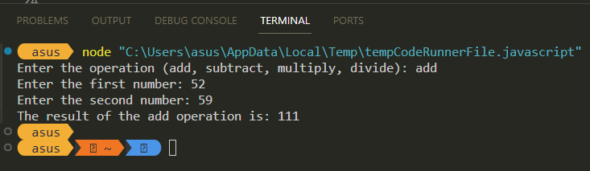

**Alternatively, HTML can also be integrated with Javascript to give a more visually appealing experience. Here is the HTML+Javascript code for calculator.**

<!DOCTYPE html>

<html lang="en">

<head>

    <meta charset="UTF-8">

    <meta name="viewport" content="width=device-width, initial-scale=1.0">

    <title>Simple Calculator</title>

    <style>

        input[type="button"] {

*width*: 50px;

*height*: 50px;

*font-size*: 20px;

*margin*: 5px;

        }

    </style>

</head>

<body>

    <h2>Simple Calculator</h2>

    <input type="text" id="display" disabled>

    <br>

    <script>

        // Function to update the display

*function* updateDisplay(*value*) {

            document.getElementById('display').value = *value*;

        }

        // Function to perform calculation

*function* calculate() {

            try {

                updateDisplay(eval(document.getElementById('display').value));

            } catch (error) {

                updateDisplay('Error');

            }

        }

        // Function to clear the display

*function* clearDisplay() {

            updateDisplay('');

        }

        // Function to append the clicked button value to the display

*function* appendToDisplay(*value*) {

            document.getElementById('display').value += *value*;

        }

    </script>

    <!-- Calculator Buttons -->

    <table>

        <tr>

            <td><input type="button" value="7" onclick="appendToDisplay('7')"></td>

            <td><input type="button" value="8" onclick="appendToDisplay('8')"></td>

            <td><input type="button" value="9" onclick="appendToDisplay('9')"></td>

            <td><input type="button" value="/" onclick="appendToDisplay('/')"></td>

        </tr>

        <tr>

            <td><input type="button" value="4" onclick="appendToDisplay('4')"></td>

            <td><input type="button" value="5" onclick="appendToDisplay('5')"></td>

            <td><input type="button" value="6" onclick="appendToDisplay('6')"></td>

            <td><input type="button" value="*" onclick="appendToDisplay('*')"></td>

        </tr>

        <tr>

            <td><input type="button" value="1" onclick="appendToDisplay('1')"></td>

            <td><input type="button" value="2" onclick="appendToDisplay('2')"></td>

            <td><input type="button" value="3" onclick="appendToDisplay('3')"></td>

            <td><input type="button" value="-" onclick="appendToDisplay('-')"></td>

        </tr>

        <tr>

            <td><input type="button" value="0" onclick="appendToDisplay('0')"></td>

            <td><input type="button" value="." onclick="appendToDisplay('.')"></td>

            <td><input type="button" value="=" onclick="calculate()"></td>

            <td><input type="button" value="+" onclick="appendToDisplay('+')"></td>

        </tr>

        <tr>

            <td colspan="4"><input type="button" value="C" onclick="clearDisplay()"></td>

        </tr>

    </table>

</body>

</html>

**Output:**

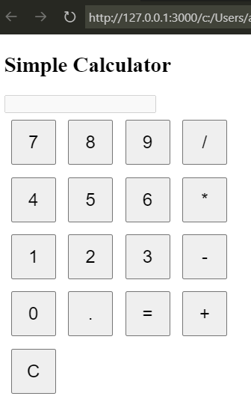

1. **Write a JavaScript function that accepts a string as a parameter and finds the longest word within the string.**

**Ans:**

*function* findLongestWord(*str*) {

*const* words = *str*.split(' ');

*let* longestWord = '';

    for (*const* word of words) {

      if (word.length > longestWord.length) {

        longestWord = word;

      }

    }

    return longestWord;

  }

  console.log(findLongestWord('The quick brown fox jumped over the lazy dog'));

  console.log(findLongestWord('This is a test string with several words'));

**Output:**

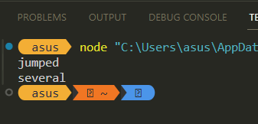

1. **Write a JavaScript program to find odd and even numbers from 1 to 100.**

**Ans:**

*function* findOddAndEvenNumbers(*num*) {

*const* oddNumbers = [];

*const* evenNumbers = [];

    for (*let* i = 1; i <= *num*; i++) {

      if (i % 2 === 0) {

        evenNumbers.push(i);

      } else {

        oddNumbers.push(i);

      }

    }

    return { oddNumbers, evenNumbers };

  }

*const* result = findOddAndEvenNumbers(100);

  console.log('Odd numbers from 1 to 100:', result.oddNumbers);

  console.log('Even numbers from 1 to 100:', result.evenNumbers);

**Output:**

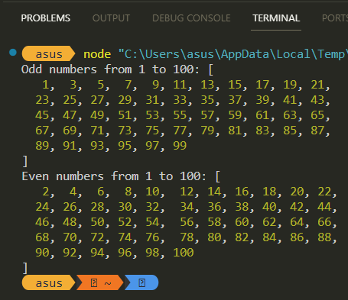

1. **Write a JavaScript program to generate a random string.**

**Ans:**

*function* generateRandomString(*length*=6) {

*const* chars = 'ABCDEFGHIJKLMNOPQRSTUVWXYZabcdefghijklmnopqrstuvwxyz0123456789';

*const* charLength = chars.length;

*let* result = '';

    for ( *let* i = 0; i < *length*; i++ ) {

      result += chars.charAt(Math.floor(Math.random() * charLength));

    }

    return result;

  }

  console.log(generateRandomString(12));

**Output:**

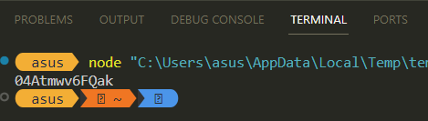

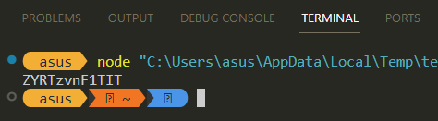

1. **Write a JavaScript Program to Print All Prime Numbers in an Interval.**

**Ans:**

*function* printPrimeNumbers(*start*, *end*) {

    for (*let* i = *start*; i <= *end*; i++) {

      if (isPrime(i)) {

        console.log(i);

      }

    }

  }

*function* isPrime(*num*) {

    if (*num* <= 1) {

      return false;

    }

    for (*let* i = 2; i <= Math.sqrt(*num*); i++) {

      if (*num* % i === 0) {

        return false;

      }

    }

    return true;

  }

  printPrimeNumbers(10, 50);

**Output:**

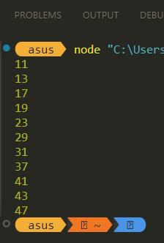

1. **Write a JavaScript program to populate a drop-down box from 1 to 1000.**

**Ans:**

<!DOCTYPE html>

<html>

<body>

  <select id="dropdown"></select>

  <script>

*const* dropdown = document.getElementById("dropdown");

    for (*let* i = 1; i <= 1000; i++) {

*const* option = document.createElement("option");

      option.value = i;

      option.textContent = i;

      dropdown.appendChild(option);

    }

  </script>

</body>

</html>

**Output:**

